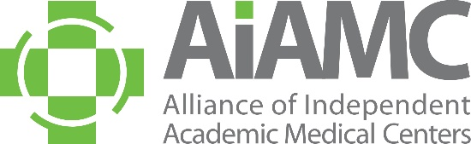

(YOUR INSTITUION’S LOGO HERE)

Dear C-Suite Leader (Enter Name Here),

As you know, (Name of Your Institution) is one of twenty-one hospitals nationwide that has been chosen to participate in the AIAMC’s National Initiative X: Optimizing the Clinical Learning Environment For the Future. Our team has been completing pre-work for the past couple of months, and we are very excited to attend the first meeting of National Initiative X, to be held October 16th and 17th at the Omni Chicago. My purpose in reaching out is to invite you to attend this kick-off meeting with me. (List Names) will also be in attendance, and we would be honored to have you join us.

(Name of Your Institution’s) project entitled, “(Title of Your Project”) aims to (briefly describe your project and its anticipated outcomes).

We believe this work is vital, as the clinical learning environment is the foundation of graduate medical education, directly shaping the professional development, well-being, and competency of future physicians. The rapidly evolving landscape of modern healthcare, including emerging technologies, workforce shortages, and growing complexity of patient care, demands that physicians are trained in settings that promote adaptability, lifelong learning, and resilience. Strengthening the clinical learning environment ensures that training is optimized to support high-quality learning while prioritizing patient safety and quality interprofessional collaboration, and physician well-being. Further, standardizing best practices across institutions can help to foster equitable learning experiences, strengthen professional identity formation, and ultimately improve patient outcomes. Evidence indicates that a well-supported clinical learning environment contributes to improved trainee engagement, reduced burnout, and higher retention rates, directly benefiting both learners and the healthcare system. By investing in the clinical learning environment, GME programs can create sustainable learning environment not only to meet the challenges of healthcare but also to lead its transformation.

To show our collective appreciation for your participation and support, the AIAMC has agreed to waive the registration fee for C-Suite leaders. Please visit National Initiative X Meeting One | AIAMC and choose the “Team Leader” option at $0. To make your hotel reservation at the Omni Chicago, click on this direct booking link: https://bookings.omnihotels.com/event/chicago/AIAMC-2025-National-Initiative-Meeting-10082025.

I do hope your schedule will allow you to join us in Chicago and thus ensure our team a most strong start as we launch this important work!

Sincerely,

Your Name
Your Title

